16 La Vaguada (c/. Málaga)
Urbanización Caleta del Sol
E-29751 Caleta de Vélez
James.Wimberley@gmail.com

Open letter to Pope Leo XIV

Your Holiness’ predecessor addressed his great Encyclical Laudato Si’ to all those striving to protect our beautiful world from destruction (paragraphs 13 -14). He invited non-Catholics to join in a productive dialogue to secure this. I would like to take up this generous and far-sighted offer.

The central teaching of Laudato Si’ is true and some of its expression is inspired. But not all. I draw your attention to a paragraph where I submit Pope Francis made a significant mistake, that contradicts another groundbreaking encyclical, Leo XIII’s Rerum novarum. This not a textual niggle: encyclicals are considered documents and everything in them deserves to be taken seriously, by Catholics and others.

Laudate Si’, paragraph 55, emphasis added :
“[...] People may well have a growing ecological sensitivity but it has not succeeded in changing their harmful habits of consumption which, rather than decreasing, appear to be growing all the more. A simple example is the increasing use and power of air-conditioning. The markets, which immediately benefit from sales, stimulate ever greater demand. An outsider looking at our world would be amazed at such behaviour, which at times appears self-destructive.”

It is in my humble opinion a mistake to condemn air conditioning as a superfluous luxury, for both pragmatic and theological reasons.

The world is inexorably getting hotter. TV weather programmes regularly report daytime temperatures of 50 degrees C in the Middle East and the Indian subcontinent. Such temperatures are an immediate danger to life. Physical work outside becomes not difficult but impossible. For the inhabitants of Qetta, Riyadh, and Baghdad, and many other cities and villages, air conditioning is not a luxury but a necessity.

The danger from heat at work is very large. From the latest ILO report (pdf):
“ At least 2.41 billion workers – 71 per cent of the working population – are exposed to excessive heat, resulting in 22.85 million injuries and 18,970 deaths annually.“ Much of the exposure is to farm workers, and can be cut by a simple change in working hours. Much is in factories , offices, and shops where the only technical solution is air conditioning.

This is where Laudate Si’ collides with Rerum novarum. Pope Leo XIII endorsed state regulation of working conditions to protect the health and dignity of workers:

Paragraph 36: “.. if employers laid burdens upon their workmen which were unjust, or degraded them with conditions repugnant to their dignity as human beings; finally, if health were endangered by excessive labor, or by work unsuited to sex or age - in such cases, there can be no question but that, within certain limits, it would be right to invoke the aid and authority of the law.”

Paragraph 42: “ Daily labor, therefore, should be so regulated as not to be protracted over longer hours than strength admits. How many and how long the intervals of rest should be must depend on the nature of the work, on circumstances of time and place, and on the health and strength of the workman. Those who work in mines and quarries, and extract coal, stone and metals from the bowels of the earth, should have shorter hours in proportion as their labor is more severe and trying to health. Then, again, the season of the year should be taken into account; for not unfrequently a kind of labor is easy at one time which at another is intolerable or exceedingly difficult.”

I don’t find this conflict difficult to resolve. Leo was right in general and his position implies regulation of temperatures at work. Francis was on this point regrettably mistaken. Rome is a hot city. Among many others, those who work in the Vatican offices deserve air conditioning to be able to work productively and with dignity.

The need is even greater for the staff and patients in hospitals, many of which are run by Catholic charities and religious orders. Private homes are increasingly workplaces too, as well as spaces for family life – which also deserves reasonable temperatures to flourish.

Air conditioning can of course be overdone and cold air becomes a wasteful status symbol. This is quite rare in my experience. There are far better examples of conspicuous consumption, like the huge yachts and private jets of oligarchs. It is even more offensive when intolerable heat is imposed on workers by managers sitting in air-conditioned office suites.

The mistake may come from a general anxiety about wasting energy with which your generation – also mine – grew up. Air conditioners run on electricity, and electricity came from power stations burning coal, oil and natural gas, poisoning the atmosphere. We were brought up to turn off the lights on leaving a room empty. About half the world’s electricity is still generated this way, but the share is declining fast. The Spanish grid supply for instance is now over 85% zero-carbon, more in the summer when a/c demand peaks – as does solar output. A future of energy abundance, from practically limitless and God-given renewable wind and solar, plus mountains to store it in, is within our grasp. Of course, humans should still avoid wasteful use of energy, as other physical and financial resources are involved, but these concerns are quite low on the list of problems before us. We can have air conditioning everywhere it is needed with a clear conscience.

A final thought from the Psalms. Palestine is a hot country. The author of Psalm 42 wrote from experience when they likened God’s grace to cool water (KJV) :
As the hart panteth after the water brooks, so panteth my soul after thee, O God.
Handel, Mendelssohn and others have set these beautiful words to music. Let us rejoice in both blessings.

Yours sincerely
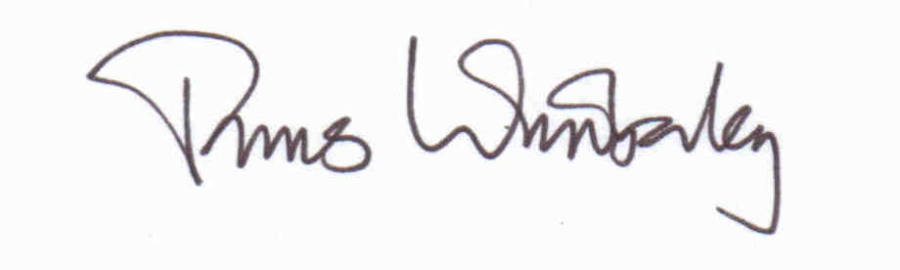

James Wimberley Anglican layman, retired, resident in Spain

Caleta de Velez, 16 June 2025

PS 1. I declare that I have no personal or financial connection to the air-conditioning industry other than that of a satisfied customer.
PS 2. This letter is not confidential and may be freely distributed and cited, I trust accurately.
PS 3. A purely technical niggle: air conditioners do not, as Laudate Si, implies, use ever-increasing power, and have become much more efficient with heat pump technology. There are of course many more of them, so the total electricity demand for this purpose has naturally and properly gone up.

Download at http://www.jameswimberley.es/Notes/Pope air conditioning.docx

